To run the C#.NET Tutorials you have to do the next steps:
- Create a C#.NET Console Application.
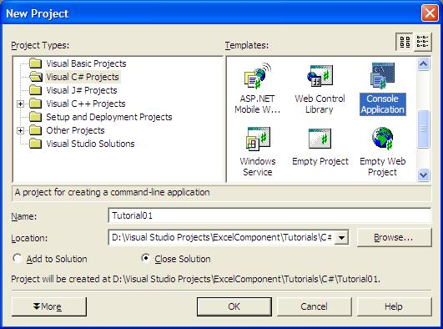
- Add reference to the EasyXLS.dll file and other necessary files.
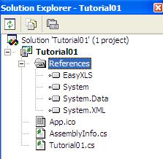

Tutorials 2, 5, 6, 7, 8, 9, 14, 22 and 23 need reference to System.Drawing.dll file from .NET Framework, too.
Tutorials 1, 2, 32 and 41 need reference to System.Xml.dll file, too.
- Replace the file Tutorial01.cs with the one provided by us.
- Run the project.

